**EXTERNALIZING URLS IN AEM**

In AEM, the **Externalizer** is an OSGI service that allows you to programmatically transform a resource path (e.g. **/path/to/my/page**) into an external and absolute URL (for example, **http://www.mycompany.com/path/to/my/page**) by prefixing the path with a pre-configured DNS.

Because an instance cannot know its externally visible URL if it is running behind a web layer, and because sometimes a link has to be created outside of the request scope, this service provides a central place to configure those external URLs and build them.

This page explains how to configure the **Externalizer** service and how to use it.

**Configuring the Externalizer service**

The **Externalizer** service allows you to centrally define multiple domains that can be used to programmatically prefix resource paths. Each domain is identified by a unique name that is used to programmatically reference the domain.

To define a domain mapping for the **Externalizer** service:

1. Navigate to the configuration manager via **Tools**, then**Web Console**, or enter **http://<host>:<port>/system/console/configMgr.**
2. Click **Day CQ Link Externalizer** to open the configuration dialog box.

**Note:**

The direct link to the configuration is **http://<host>:<port>/system/console/configMgr/com.day.cq.commons.impl.ExternalizerImpl**

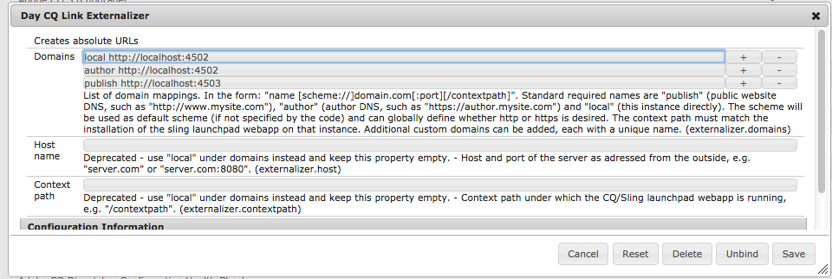

1. Define a domain mapping: a mapping consists of a unique name that can be used in the code to reference the domain, a space and the domain:  
   **<unique-name> [scheme://]server[:port][/contextpath]**, where:
   * **scheme** is usually http or https, but can also be ftp etc.; use https to enforce https links if desired; it will be used if the client code does not override the scheme when asking for externalization of a URL.
   * **server** is the host name (can be a domain name or ip address).
   * **port** (optional) is the port number.
   * **contextpath** (optional) is only set if AEM is installed as a webapp under a different context path.

For example: **production http://my.production.instance**  
The following mapping names are predefined and must always be set as AEM relies on them:

* + **local** - the local instance
  + **author** - the authoring system DNS
  + **publish** - the public facing website DNS

**Note:**

A custom configuration allows you to add a new category, such as "production," "staging," or even external non-AEM systems such as "my-internal-webservice" and is useful to avoid hardcoding such URLs across different places in a project's codebase.

1. Click **Save** to save your changes.

**Note:**

Adobe recommends that you [add the configuration to the repository](https://helpx.adobe.com/experience-manager/6-3/sites/deploying/using/configuring.html#AddingaNewConfigurationtotheRepository).

**Using the Externalizer service**

This section shows a few examples of how the **Externalizer** service can be used.

**To get the Externalizer service in a JSP:**

Externalizer externalizer = resourceResolver.adaptTo(Externalizer.class);

**To externalize a path with the 'publish' domain:**

String myExternalizedUrl = externalizer.publishLink(resolver, "/my/page") + ".html";

Assuming the domain mapping "publish http://www.website.com", myExternalizedUrl ends up with the value "http://www.website.com/contextpath/my/page.html".

**To externalize a path with the 'author' domain:**

String myExternalizedUrl = externalizer.authorLink(resolver, "/my/page") + ".html";

Assuming the domain mapping "author http://author.website.com", myExternalizedUrl ends up with the value "http://author.website.com/contextpath/my/page.html".

**To externalize a path with the 'local' domain:**

String myExternalizedUrl = externalizer.externalLink(resolver, Externalizer.LOCAL, "/my/page") + ".html";

Assuming the domain mapping "local http://publish-3.internal", myExternalizedUrl ends up with the value "http://publish-3.internal/contextpath/my/page.html".